Bon Appetit

Software Requirements Specification

2.0

09/06/2019

**Priyanka Galla**

**Naga Sai Manoj Goppisetty**

**Nithya Vudayamarri**

**Nikitha Mandala**

**Lahari Thamatam**

**Vijaya Raja Mayuri Akula**

**Harshavardhan Reddy Bollam**

Submitted in partial fulfilment

Of the requirements of

CSIS 44-691 Graduate Directed Project 1

**Revision History**

|  |  |  |  |
| --- | --- | --- | --- |
|  |  |  |  |
| **Date** | **Description** | **Author** | **Comments** |
| 09/06/2019 | Version 2.0 | Priyanka Galla  Naga Sai Manoj Goppisetty  Nithya Vudayamarri  Nikitha Mandala  Lahari Thamatam  Vijaya Raja Mayuri Akula  Harshavardhan Reddy Bollam | First Revision |
|  |  |  |  |
|  |  |  |  |

# **Document Approval**

The following Software Requirements Specification has been accepted and approved by the following:

|  |  |  |  |
| --- | --- | --- | --- |
| **Signature** | **Printed Name** | **Title** | **Date** |
|  |  |  |  |
|  |  |  |  |
|  |  |  |  |

**Table of Contents**

**Table of Contents Page Number**

1.Introduction

1.1.Purpose 5

1.2.Scope 5

1.3.Definitions, Acronyms, and Abbreviations 5

1.4.References 5

1.5.Overview  5

2.General Description

2.1.Product Perspective 5

2.2.Product Functions  5

2.3.User Characteristics 5

2.4.General Constraints 5

2.5.Assumptions and Dependencies 5

3. Specific Requirements

3.1.External Interface Requirements 5

3.1.1.User Interfaces 5

3.1.2.Hardware Interfaces 5

3.1.3.Software Interfaces 5

3.1.4.Communications Interface 5

3.2. Functional Requirements 6

3.3. Use Cases 6

3.4. Class/Objects 6

3.5. Non-Functional Requirements 6

3.5.1. Performance 6

3.5.2. Reliability 6

3.5.3. Availability 6

3.5.4. Security 6

3.5.5. Portability 6

3.6. Inverse Requirements 6

3.7. Design Constraints 7

3.8. Logical Database Requirements 7

3.9. Other Requirements 7

3.10. Prototypes (for complete project) 7

3.11. Use Case Diagrams 7

4. Design

4.1. ER diagram

4.2. GUI

5.Analysis Models

5.1. Data Flow Diagram

5.2. Sequence Diagram

6. Technical Manual

1. **Introduction**

**1.1 Purpose:** The purpose is it is a modern day application for delivering food to the doorstep from favorite restaurants nearby with fastest delivery services and easy accessibility .

**1.2 Scope:** This is a food delivery web page along with an authentication and a new user can login through their credentials. User can search for different restaurants & cuisines in different locations. After placing the order the user is directed to the payment page, once the payment is done user will get a popup message like the order is placed successfully and users can track their order.

**1.3 Definitions, Acronyms, and Abbreviations**

**1.4. References**

**1.5. Overview:**

In this application, we will be developing a Home Page, Login Page, a Menu for all the restaurants we are tied-up with, allows the users to place their food Orders, also allows them to give their Ratings and Reviews for orders they placed and for the help from customer care if they got any, a Payment Page, a facility to apply Promotional Codes and use various restaurant provided and app provided Deals.

**2. General Description**

**2.1. Product Perspective**

**2.2. Product Functions**

With this product, the users will be able go and check the different types of food available in different restaurants nearby. The user is given with an account which is linked to their mail, so that user will be able to access the orders and deals available. User can also send the selected items to the cart, they can view the reviews of the restaurant, nearby restaurants details, timings, menu and many more features. Additionally, the app provides the regular users exciting offers, coupons for new users to increase the users for the app.

**2.3. User Characteristics**

**2.4. General Constraints**

**2.5. Assumptions and Dependencies**

**3. Specific Requirements**

**3.1. External Interface Requirements**

3.1.1. User Interfaces

* A good user interface provides a "user-friendly" experience.
* GUI of our software program includes many user-friendly controls like
* A Menu Bar
* Input Selector
* Images
* Buttons, etc.

3.1.2. Hardware Interfaces

* This application is based on Web Development.
* Pentium Processor
* 60 MB of free hard-drive space
* 128 MB of RAM

3.1.3. Software Interfaces

* Operating System: Windows (Vista/7 or above)
* Web Browser: IE 10 or above, Mozilla FF 31 and above or Google Chrome
* Database used: MongoDB
* Drivers: Java Runtime Environment
* Integrated Development Environment: Eclipse J2EE or Apache Tomcat, Visual Studio, HTML, CSS and JavaScript.

**3.2. Functional Requirements**

**Home Page:** In home page we have search text box, search button where the users can search for cuisines and restaurants.

**Login Page:** Registered users can login with their username and password. New users can sign up. If users forget their password they can reset their password using email.

**Menu:** The users can view menu for any restaurant by clicking the menu.  
**Orders:** Items which are ordered can be viewed in orders.

**Ratings and Reviews:** Users can give rating and review for a restaurant and view the other ratings and reviews also.

**Payment :** Users can pay using their credit/debit card and cash on delivery.

**Promotional Codes:** Using this code users can get a discount on the order.

**Deals:** Users can view deals applicable on any particular restaurant.

**3.2. Functional Requirements**

**3.3. Use Cases**

**3.4. Class/Objects**

**3.5. Non-Functional Requirements**

**3.5.1. Performance:**

Requirements about resources required, response time, transaction rates, throughput, benchmark specifications or anything else having to do with performance.

**3.5.2. Reliability:**

Requirements about how often the software fails. The measurement is often expressed in MTBF (mean time between failures). The definition of a failure must be clear. Specify the consequences of software failure, how to protect from failure, a strategy for error detection, and a strategy for correction.

**3.5.3. Availability:**

Availability is gauged by the period of time that the system’s functionality and services are available for use with all operations.

**3.5.4. Security:**

One or more requirements about the protection of your system and its data. The measurement can be expressed in a variety of ways (effort, skill level, time ...) to break into the system.

**3.5.5. Portability:**

The effort required to move the software to a different target platform. The measurement is most commonly person-months or % of modules that need changing.

**3.6. Inverse Requirements**

**3.7. Design Constraints**

**3.8.Logical Database Requirements**

**3.9.Other Requirements**

**3.10. Prototypes (for complete project)**

**3.11. Use Case Diagrams**

**4. Design**

**4.1. ER diagram**

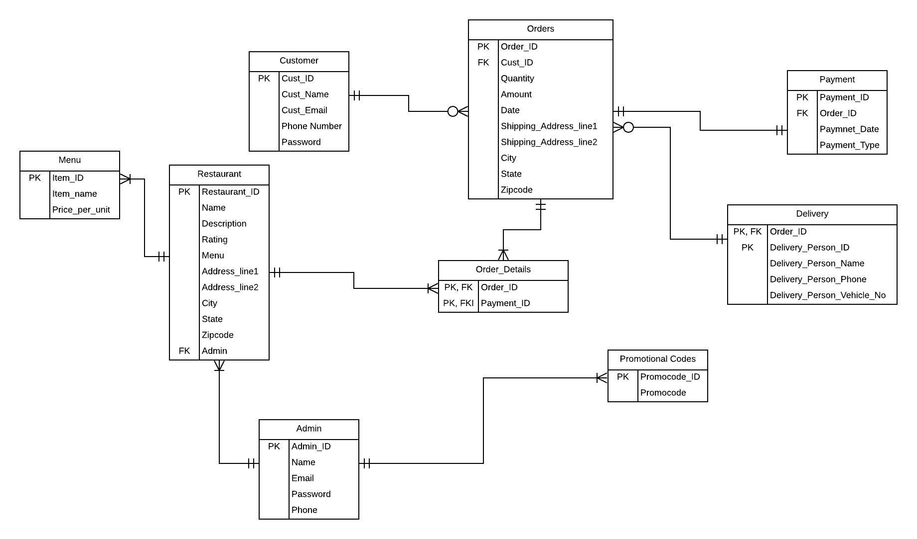

**In the above Entity Relationship diagram, it has 9 entities namely Customer, Restaurants, Admin, Orders, Order_details, Promotional codes, Menu, Delivery and payment. The customer can be considered as user and admin can be considered as seller. So in the above diagram, we can also see that we have only one associative entity that is Order_details which is a weak entity. Customer_id, Restaurant_id, Admin_id, Order_id, Promocode_id, Payment_id, Menu_id,Delivery_id, are primary and foreign keys.**

**Relationship:**

**Customer: Orders - 1: M**

**Orders: Payment - 1: 1**

**Orders: Delivery - 1: 1**

**Orders: Order_details - 1: M**

**Restaurant: Order_details - 1: M**

**Orders: Promo codes - 1:1**

**Restaurant: Admin - 1: M**

**Admin: Promo codes - 1: M**

**4.2. GUI**

**Modified GUI:-**

* + **Home Page :**

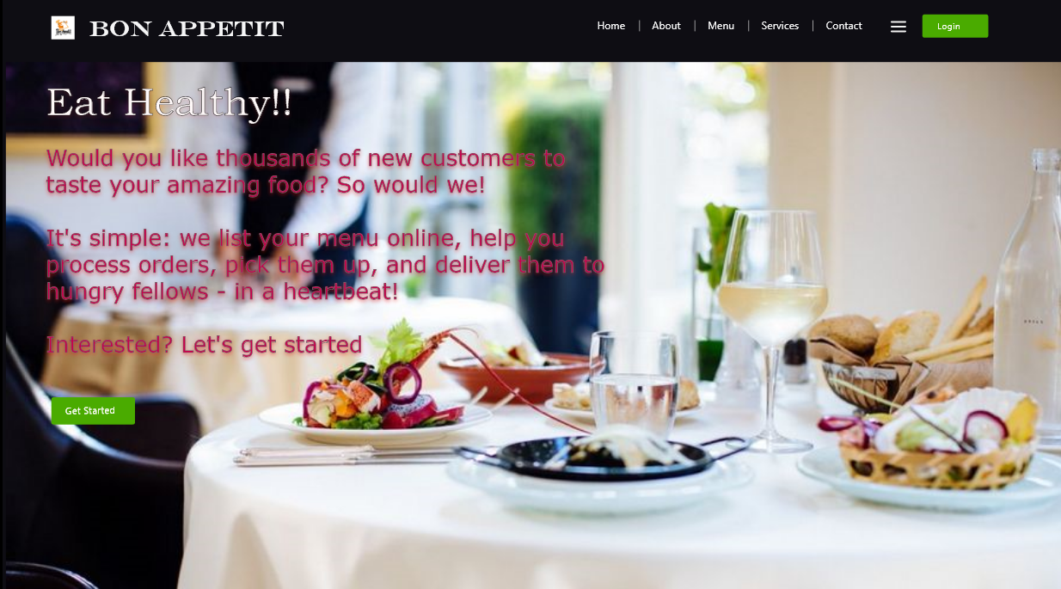

* + **Login Page:**

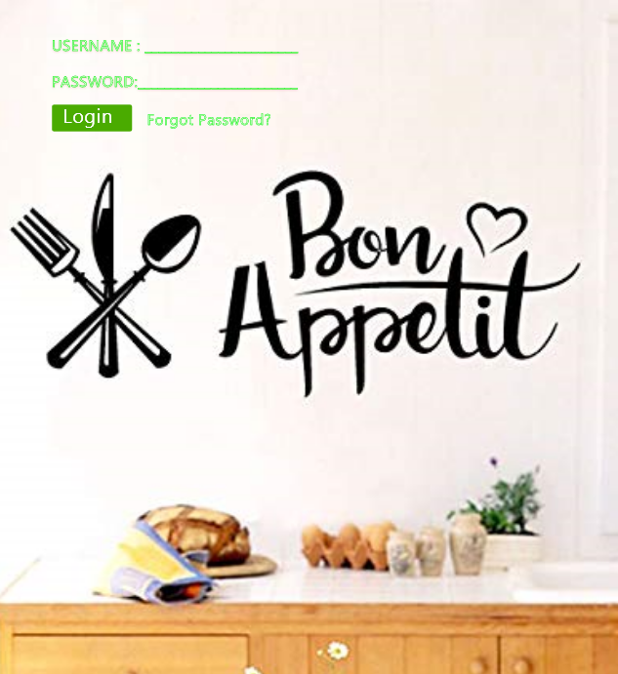

* + **Reservation Page:**

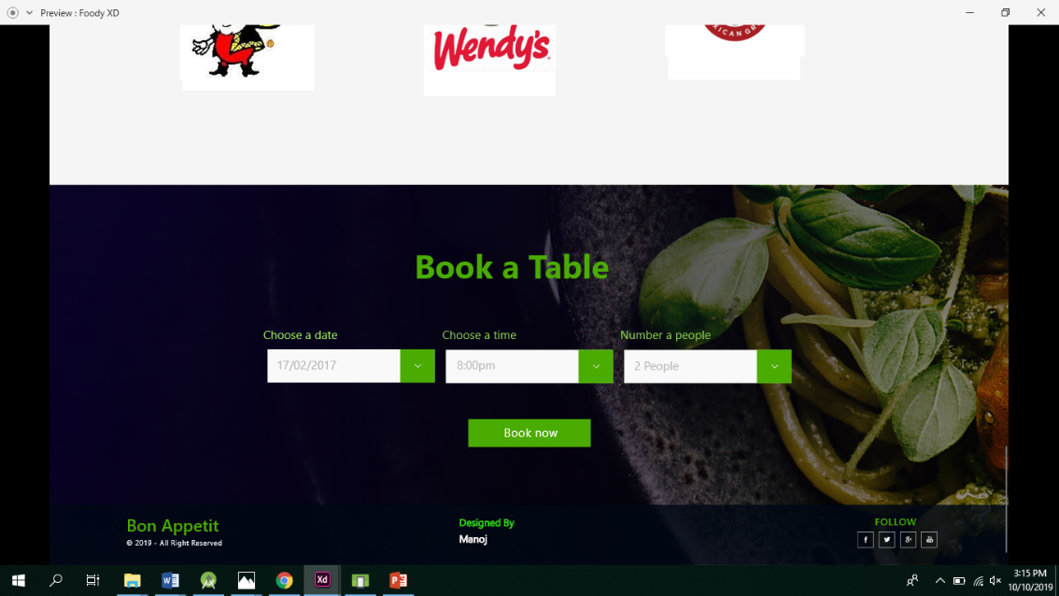

* + **Restaurant Page:**

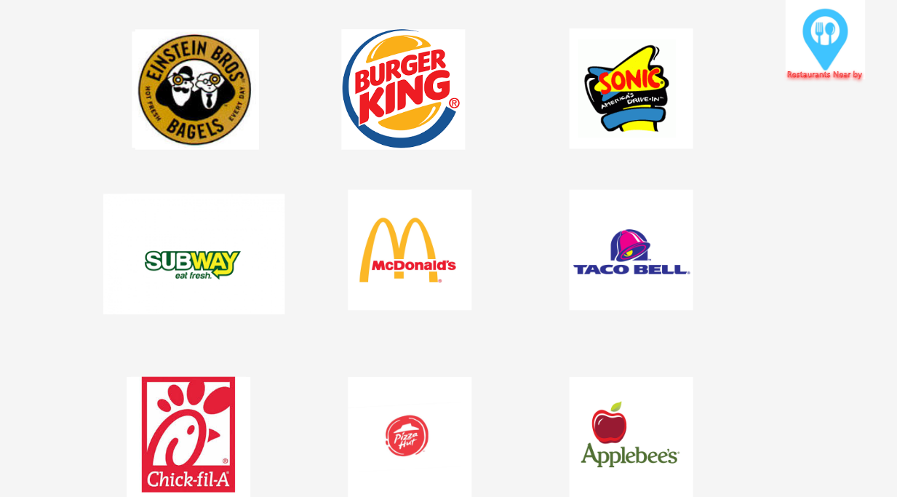

* + **Sign Up Page:**

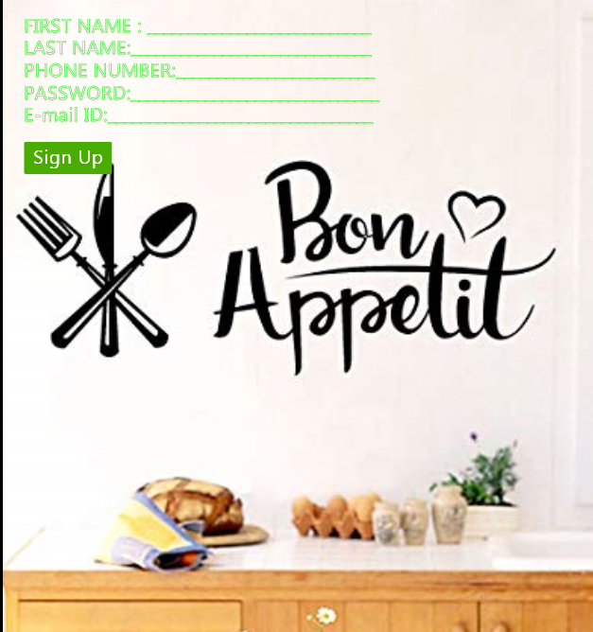

* + **About us page:**

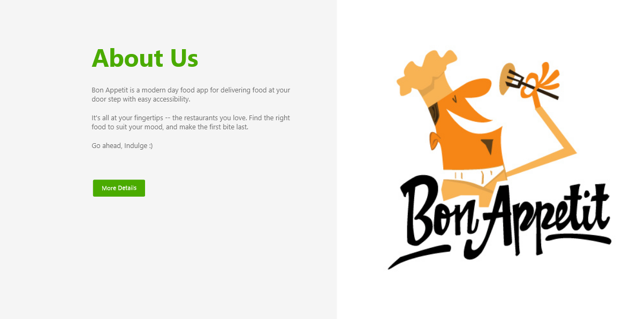

* + **Payment Page:**



**5. Analysis Models**

**5.1. Data Flow Diagram**

**5.2. Sequence Diagram**

**6. Technical Manual**

**6.1 List of Activities**

1. **Home Page Activity**
2. **About Us Activity**
3. **Restaurants Activity**
4. **Reservation Activity**
5. **Contact Activity**
6. **Sign Up Activity**
7. **Login Activity**
8. **Payment Activity**

A brief explanation of the code related to each of these activities that we have implemented so far:

**1. Home Page Activity:**

The Home Page activity of our app has all the HTML, CSS and JavaScript code that gives the user a brief overview of our app that constitutes our app logo, a search option to search for food items or restaurants and all the other copyright details etc. It also has a navigation bar on the top of the screen. This nav bar has links to the Home Page itself, the About Us page, the Restaurants page, the Reservation page, the Contact page and also two buttons that allow the user to sign in and sign up.

1. **About Us Activity:**

The About Us activity is where we have the code that gives all the detailed description of our app. For example, it gives a list of restaurants and food items that we deliver, our delivery details based on the user’s location, our order-cancellation policies etc.

1. **Restaurants Activity:**

This activity maintains and displays all the list of restaurant options that they can order food from and their brief addresses. This list of restaurants changes based on the user’s current location.

1. **Reservation Activity:**

This activity has the HTML, CSS and JavaScript to allow the user to select a restaurant, a seat in that restaurant and the time and date on which he/she wants to book that seat in that restaurant. This activity has a code on the back-end to inform the restaurant and update the seats available in the restaurant.

1. **Contact Activity:**

In contact activity we have the code that gives us all the contact information for the users in case they want to contact the customer care regarding any of their orders. It shows all the mobile numbers of the customer care and the mail ids.

1. **Sign Up Activity:**

We have a button on the nav bar of every page and also on the home page to lead us to the sign up page. This page has the front end that enables user to give all the user’s details such as name, mobile number, email etc. The back end of this page stores the details in the database that we maintain to store all the user profile.

1. **Login Activity:**

We have a button on the nav bar of every page and also on the sign up page to lead us to the login page if the user is already a member on the app. This page has the front end that enables user to enter the username and the password. The back end of this page allows the user to login to the app in order to perform all the activities on the app such as search for food items, restaurants, order food, make payments, cancellations etc. if the given credentials are correct.

1. **Payment Activity**

              Payment page is for making a payment after the users orders food. This page consists of card details(card number, cvv, expiration date),Customer name, address, phone number. For payment ,the customer should enter all the above information and can proceed to check out. This page is developed using html, css and Javascript. The user can select a card from any bank and make a payment. Once if the user cancel the payment he/she can get the refund automatically.

The user should give all the mentioned details in order to make a successful  payment.